1. **VL with Quadratic: data length, regression error, non-selt match threshold, k, alpha, anomalies, time**

(0-5000), 2,0.1,1,3,(2961-3667),00:00:08

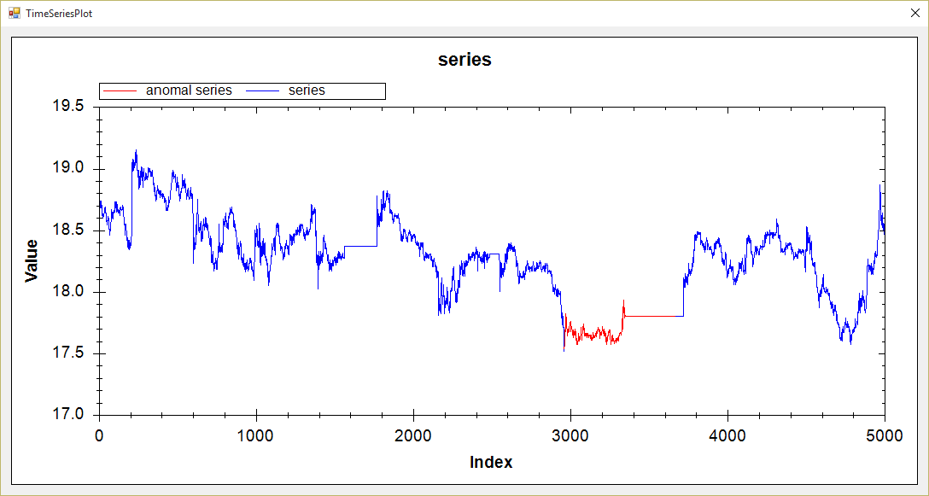

1. **VL with Extrem point: data length, ration, min length, k, alpha, anomalies, time**

(0-5000), 1.01, 200, 1, 1.5, (2960-3809), 00:00:09

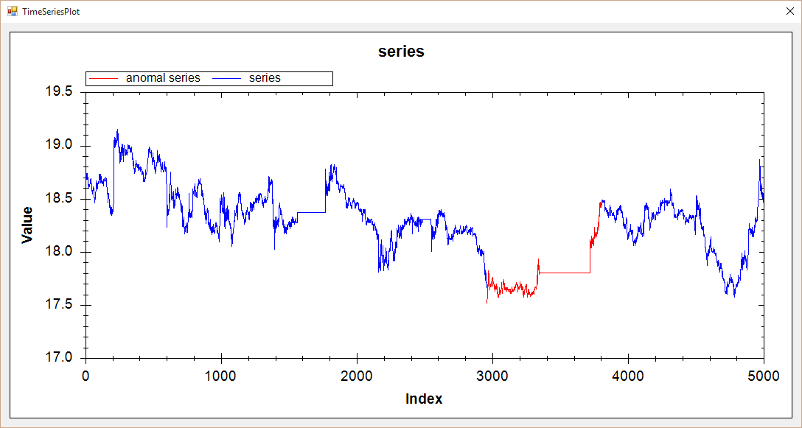

1. **Hot Sax: data length, anomaly length, paa length, discord begin, time**

(0-5000), 700, 70, 2949,00:01:34

